Student Coding Homework Assignment Submission (Max 10 points)
1. Student Registration Information
- Full Name: Nico Milette, Jose Solano, Stephen Secor
- Student ID: njm21, jls23k, sas24e
- Course Name: CIS4930
- Instructor Name: [Dr Ahsan Abdullah]
- Date of Submission (mm-dd-yyy): 02-21-2025

2. Assignment Overview (1 point)
- Assignment Title: Phase-I NER Domain Project: “Travel and Tourism“
- Assignment Objectives:
  - Train an NER model to recognize and highlight specific entities related to the domain in a given text.
  - Build a user friendly graphical interface.
  - Include 1200-1500 word domain specific sample pdf file used to train and test the model.

3. Code
- Code Implementation (2 points):
"""
Full Name: Nico Milette, Jose Solano, Stephen Secor
Student ID: njm21, jls23k, sas24e
Course Name: CIS4930
Instructor Name: [Dr Ahsan Abdullah]
Date of Submission (mm-dd-yyy): 02-21-2025
"""

import spacy
import threading
from tkinter import *
from tkinter import ttk
from spacy.training import Example
from trainingModel import TRAINING_DATA

# Model Path Configuration
MODEL_PATH = "custom_trained_model"

# Entities linked to specific colors
ENTITY_COLORS = {
"GPE": "lightblue",
"LOC": "lightgreen",
"ORG": "lightcoral",
"FAC": "lightyellow",
"DATE": "lightpink",
"MONEY": "lightgray",
"EVENT": "lightgoldenrodyellow",
"PERSON": "lavender",
"PRODUCT": "gold",
"TIME": "lightsteelblue",
}

# Entity labels for easier recognizing
ENTITY_LABELS = {
"GPE": "Geopolitical Entity",
"LOC": "Location",
"ORG": "Organization",
"FAC": "Facility",
"DATE": "Date",
"MONEY": "Money",
"EVENT": "Event",
"PERSON": "Person",
"PRODUCT": "Product",
"TIME": "Time",
}

class NERModel:
def __init__(self, model_path=MODEL_PATH):
self.model_path = model_path
self.custom_nlp = self.load_model()
self.default_nlp = spacy.load("en_core_web_sm") # Load the default model

# Load existing model or fallback to en_core_web_sm
def load_model(self):
try:
return spacy.load(self.model_path)
except Exception as e:
print(f"Error loading custom model: {e}")
return spacy.load("en_core_web_sm")

# Train model with provided training data
def train_model(self):
print("Training started...")

if "ner" not in self.custom_nlp.pipe_names:
ner = self.custom_nlp.add_pipe("ner")
else:
ner = self.custom_nlp.get_pipe("ner")

# Add labels from TRAINING_DATA
for text, annotations in TRAINING_DATA:
for start, end, label in annotations["entities"]:
ner.add_label(label)

training_examples = [
Example.from_dict(self.custom_nlp.make_doc(text), annotations)
for text, annotations in TRAINING_DATA
]

unaffected_pipes = [pipe for pipe in self.custom_nlp.pipe_names if pipe != "ner"]
with self.custom_nlp.disable_pipes(*unaffected_pipes):
optimizer = self.custom_nlp.resume_training()
for epoch in range(10):
for example in training_examples:
self.custom_nlp.update([example], drop=0.5, sgd=optimizer)

self.save_and_reload_model()

# Save and reload the trained model
def save_and_reload_model(self):
self.custom_nlp.to_disk(self.model_path)
print("Training complete. Model saved.")
self.reload_model()

# Reload model
def reload_model(self):
self.custom_nlp = self.load_model()
print("Custom model reloaded.")

# Train and then highlight entities (from both models) in the provided text
def train_and_highlight(self, text, entity_vars, output_widget):
def train_process():
self.train_model()
output_widget.after(
100,
lambda: self.highlight_entities(text, entity_vars, output_widget)
)
threading.Thread(target=train_process, daemon=True).start()

# highlight function for the entities
def highlight_entities(self, text, entity_vars, output_widget):
try:
doc_custom = self.custom_nlp(text)
doc_default = self.default_nlp(text)
except Exception as e:
print(f"Error processing text: {e}")
return

# Combine and sort entities by start_char
all_ents = list(doc_custom.ents) + list(doc_default.ents)
all_ents.sort(key=lambda e: e.start_char)

# Enable editing before inserting new text
output_widget.config(state="normal")
output_widget.delete("1.0", "end") # Clear previous output

last_end = 0
for ent in all_ents:
output_widget.insert("end", text[last_end:ent.start_char])
if ent.label_ in entity_vars and entity_vars[ent.label_].get():
output_widget.insert("end", f"{ent.text} ({ent.label_})", (ent.label_,))
else:
output_widget.insert("end", ent.text)
last_end = ent.end_char

output_widget.insert("end", text[last_end:]) # Insert remaining text

# Apply tag colors
for entity, color in ENTITY_COLORS.items():
output_widget.tag_config(entity, background=color, foreground="black")

# Make output read-only
output_widget.config(state="disabled")

# function for gui for the entity highlighting
def gui(model: NERModel):
global text_entry, output_text, entity_vars
root = Tk()
root.title("Travel & Tourism NER Highlighter")
root.geometry("900x700")

mainframe = ttk.Frame(root, padding="10")
mainframe.grid(column=0, row=0, sticky=(N, W, E, S))
root.columnconfigure(0, weight=1)
root.rowconfigure(0, weight=1)

ttk.Label(mainframe, text="Enter text for entity highlighting:", font=("Arial", 12)).grid(
column=0, row=0, sticky=W
)
text_entry = Text(mainframe, width=80, height=10, wrap="word", font=("Arial", 12))
text_entry.grid(column=0, row=1, columnspan=2, sticky=(W, E))

entity_vars = {label: IntVar(value=1) for label in ENTITY_LABELS.keys()}
checkbox_frame = ttk.Frame(mainframe)
checkbox_frame.grid(column=0, row=2, columnspan=2, sticky=W, pady=10)

i = 0
for label, full_name in ENTITY_LABELS.items():
color = ENTITY_COLORS.get(label, "white")
check = Checkbutton(
checkbox_frame,
text=full_name,
variable=entity_vars[label],
bg=color,
fg="black",
activebackground=color,
selectcolor=color
)
check.grid(row=i // 2, column=i % 2, sticky=W, padx=5, pady=2)
i += 1

ttk.Button(
mainframe,
text="Train & Highlight Entities",
command=lambda: model.train_and_highlight(
text_entry.get("1.0", "end-1c"), entity_vars, output_text
),
).grid(column=0, row=3, sticky=W)

ttk.Label(mainframe, text="Highlighted output:", font=("Arial", 12)).grid(
column=0, row=4, sticky=W
)
output_text = Text(mainframe, width=80, height=15, wrap="word", font=("Arial", 12))
output_text.grid(column=0, row=5, columnspan=2, sticky=(W, E))

output_text.config(state="disabled")

for child in mainframe.winfo_children():
child.grid_configure(padx=5, pady=5)
text_entry.focus()

root.mainloop()

if __name__ == "__main__":
model = NERModel()
gui(model)

TRAINING_DATA = \
[
("Tourists can now access different sources of information, and they can generate their own content and share their views and experiences. ", {"entities": [(0, 8, "PERSON")]}), # tourist
("In addition, travel is one of the dominant topics on social media, for example on Facebook and Twitter (Neidhardt et al., 2017; Travelmail Reporter,2013).",{"entities": [(95, 102, "ORGANIZATION")]} ),
("Consider the local communities whose rich cultures are rooted in nature, beautiful landscapes, coastal resorts, majestic mountain ranges, and the exquisite diversity of wildlife.", {"entities": [(73, 93, "LOCATION")]}),
("Consider the local communities whose rich cultures are rooted in nature, beautiful landscapes, coastal resorts, majestic mountain ranges, and the exquisite diversity of wildlife.",{"entities": [(95, 110, "LOCATION")]}),
("Although travelers from Mexico are physically on U.S. soil when they visit the United States, the goods and services they consume while in America are U.S. exports.",{"entities": [(9, 18, "PERSON")]} ),
("Gumbalimba Park is a family-friendly attraction that offers its visitors to Roatan the opportunity to mingle with friendly white-face Capuchin monkeys and free-flying exotic birds (Including macaws, parrots, and hummingbirds). ", {"entities": [(37,47,"EVENT")]}),
("Gumbalimba Park is a family-friendly attraction that offers its visitors to Roatan the opportunity to mingle with friendly white-face Capuchin monkeys and free-flying exotic birds (Including macaws, parrots, and hummingbirds). ", {"entities": [(64,72, "PERSON")]}),
("Visitors can spot indigenous lizards and iguanas all around the park.", {"entities": [(0,8,"PERSON")]}),
("in which includes travel spending by Mexican visitors to the U.S, education-related expenses by Mexicans in the U.S.", {"entities": [(37,44,"PERSON")]} ),
("The Los Glaciares National Park is an area of exceptional natural beauty, with rugged, towering mountains and numerous glacial lakes, including Lake Argentino, which is 160 km long.", {"entities": [(144,158, "LOCATION")]}),
("This study aims to investigate the potential tourism value of Debre Aron Monastery, which is one of the most overlooked religious sites in northern Ethiopia.", {"entities": [(120,135, "LOCATION")]}),
("Whether youre storing up to 77 beer cans or freshly caught fish, the Tundra 65 is more than capable of keeping its cargo safe and cold.", {"entities": [(31,35, "PRODUCT")]}),
("This seven-piece set includes one large, three medium, and two small packing cubes, plus a shoe bag that’ll help you organize your items and maximize the space in your luggage.", {"entities": [(168,176,"PRODUCT")]}),
("plus a shoe bag that’ll help you organize your items and maximize the space in your luggage.", {"entities": [(7,15,"PRODUCT")]}),
("This Cabeau Evolution S2 Travel Pillow will help keep you comfy with its plush, dual-density memory foam material.",{"entities": [(32,38, "PRODUCT")]} ),
("For instance, around one in three travellers in the US, Saudi Arabia, and the UAE said they were likely to fly in first or business class, compared to the global average of just one in five28.",{"entities": [(34,44, "PERSON")]}), # travellers # british spelling...
("International travel is the more popular choice for luxury travellers who book premium flight cabins, as nearly 82% of business and first-class flight bookings on Trip.com in 2022 were for international routes. ", {"entities": [(189,202,"EVENT")]}), # International
("A Skyscanner survey also reported a strong demand for premium cabins, particularly in markets with higher GDP per capita. ", {"entities": [(54,68,"PRODUCT")]}), # Premium cabins
("According to ForwardKeys data, passengers in premium flight cabins were around 60% below 2019 levels in the first quarter of 2022. ", {"entities": [(31,41,"PERSON")]}), # Passengers
("International travel is the more popular choice for luxury travellers who book premium flight cabins, as nearly 82% of business and first-class flight bookings on Trip.com in 2022 were for international routes. ", {"entities": [(87,93,"PRODUCT")]}), #flight

]

4. Results Screenshot (1 point)
These screenshots show the graphical user interface and text highlighted as output stating the entities each word is related to. Using different colors for each entity to improve visibility.
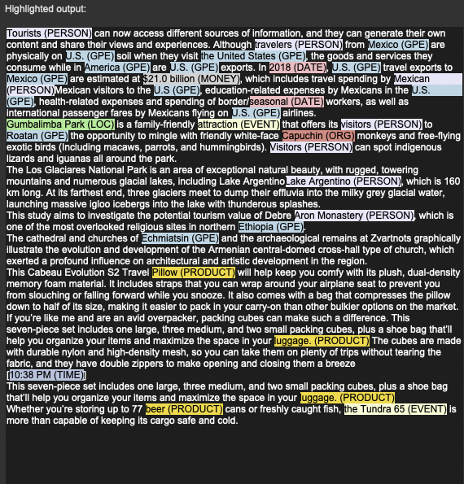
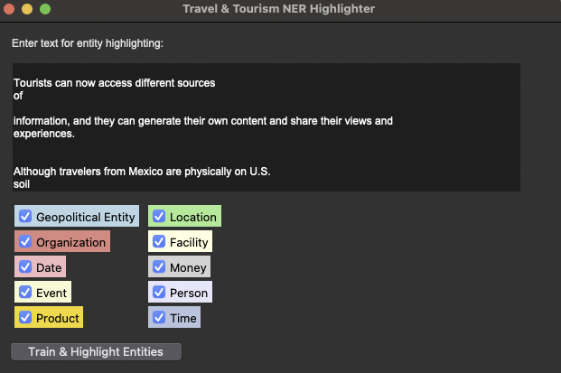
- Screenshots

5. Data Generated (2 points)
Input: This is from the file named: CIS4930 NER Training Data
Tourists can now access different sources of
information, and they can generate their own content and share their views and experiences.
Although travelers from Mexico are physically on U.S. soil
when they visit the United States, the goods and services
they consume while in America are U.S. exports. In 2018,
U.S. travel exports to Mexico are estimated at $21.0 billion,
which includes travel spending by Mexican visitors to the
U.S, education-related expenses by Mexicans in the U.S.,
health-related expenses and spending of border/seasonal
workers, as well as international passenger fares by
Mexicans flying on U.S. airlines.
Gumbalimba Park is a family-friendly attraction that offers its visitors to Roatan the opportunity
to mingle with friendly white-face Capuchin monkeys and free-flying exotic birds (Including
macaws, parrots, and hummingbirds). Visitors can spot indigenous lizards and iguanas all
around the park.
The Los Glaciares National Park is an area of exceptional natural beauty, with rugged, towering
mountains and numerous glacial lakes, including Lake Argentino, which is 160 km long. At its
farthest end, three glaciers meet to dump their effluvia into the milky grey glacial water,
launching massive igloo icebergs into the lake with thunderous splashes.
This study aims to investigate the potential tourism value of Debre Aron Monastery, which is
one of the most overlooked religious sites in northern Ethiopia.
The cathedral and churches of Echmiatsin and the archaeological remains at Zvartnots
graphically illustrate the evolution and development of the Armenian central-domed cross-hall
type of church, which exerted a profound influence on architectural and artistic development in
the region.
This Cabeau Evolution S2 Travel Pillow will help keep you comfy with its plush, dual-density
memory foam material. It includes straps that you can wrap around your airplane seat to prevent
you from slouching or falling forward while you snooze. It also comes with a bag that
compresses the pillow down to half of its size, making it easier to pack in your carry-on than
other bulkier options on the market.
If you’re like me and are an avid overpacker, packing cubes can make such a difference. This
seven-piece set includes one large, three medium, and two small packing cubes, plus a shoe
bag that’ll help you organize your items and maximize the space in your luggage. The cubes are
made with durable nylon and high-density mesh, so you can take them on plenty of trips without
tearing the fabric, and they have double zippers to make opening and closing them a breeze
[10:38 PM]
This seven-piece set includes one large, three medium, and two small packing cubes, plus a
shoe bag that’ll help you organize your items and maximize the space in your luggage.CIS4930 NER Training Data.
Whether you’re storing up to 77 beer cans or freshly caught fish, the Tundra 65 is more than
capable of keeping its cargo safe and cold.
Tourists can now access different sources of
information, and they can generate their own content and share their views and experiences.
Although travelers from Mexico are physically on U.S. soil
when they visit the United States, the goods and services
they consume while in America are U.S. exports. In 2018,
U.S. travel exports to Mexico are estimated at $21.0 billion,
which includes travel spending by Mexican visitors to the
U.S, education-related expenses by Mexicans in the U.S.,
health-related expenses and spending of border/seasonal
workers, as well as international passenger fares by
Mexicans flying on U.S. airlines.
Gumbalimba Park is a family-friendly attraction that offers its visitors to Roatan the opportunity
to mingle with friendly white-face Capuchin monkeys and free-flying exotic birds (Including
macaws, parrots, and hummingbirds). Visitors can spot indigenous lizards and iguanas all around
the park.
The Los Glaciares National Park is an area of exceptional natural beauty, with rugged, towering
mountains and numerous glacial lakes, including Lake Argentino, which is 160 km long. At its
farthest end, three glaciers meet to dump their effluvia into the milky grey glacial water,
launching massive igloo icebergs into the lake with thunderous splashes.
This study aims to investigate the potential tourism value of Debre Aron Monastery, which is
one of the most overlooked religious sites in northern Ethiopia.
The cathedral and churches of Echmiatsin and the archaeological remains at Zvartnots
graphically illustrate the evolution and development of the Armenian central-domed cross-hall
type of church, which exerted a profound influence on architectural and artistic development in
the region.
This Cabeau Evolution S2 Travel Pillow will help keep you comfy with its plush, dual-density
memory foam material. It includes straps that you can wrap around your airplane seat to prevent
you from slouching or falling forward while you snooze. It also comes with a bag that
compresses the pillow down to half of its size, making it easier to pack in your carry-on than
other bulkier options on the market.
If you’re like me and are an avid overpacker, packing cubes can make such a difference. This
seven-piece set includes one large, three medium, and two small packing cubes, plus a shoe bag
that’ll help you organize your items and maximize the space in your luggage. The cubes are
made with durable nylon and high-density mesh, so you can take them on plenty of trips without
tearing the fabric, and they have double zippers to make opening and closing them a breeze
[10:38 PM]CIS4930 NER Training Data.
This seven-piece set includes one large, three medium, and two small packing cubes, plus a shoe
bag that’ll help you organize your items and maximize the space in your luggage.
Whether you’re storing up to 77 beer cans or freshly caught fish, the Tundra 65 is more than
capable of keeping its cargo safe and cold.
At the start of the recovery from pandemic restrictions in 2021, the luxury travel segment was set
to be one of the first to return to previous levels of success as many consumers finally had the
chance to use their savings and indulge and celebrate after life in lockdown. However, with each
shift in our economy, demand for luxury travel can shift too. With today’s financial pressures,
will the sector continue to thrive? In previous years, the luxury travel segment has benefitted
from the spending power of its customer base. Though a broadcategory, luxury travel generally
includes components such as private jets, yachts, premium flights, and five-star hotels. Recently,
hyper-personalisation has become important to luxury travellers too. Despite the current global
financial challenges, the luxury travel market has proven resilient. On Trip.com, the number of
bookings for five-star hotels grew by 19% in the first three quarters of 2022 compared to the
same period in 2021, taking it just 7% below pre-pandemic volumes. Euromonitor estimates that
global sales of luxury hotels expanded by an average rate of 39% in 2022, with stronger growth
rates in the Middle East and Africa (53%) and Western Europe (45%). It also forecasts that
luxury hotel sales should reach around US$ 92 billion by 2025 compared to US$ 76 billion in
2019 (in current prices). In comparison, budget hotel sales globally grew by 23%26.
The demand for luxury hotels has been accompanied by a strong demand for premium flights.
According to ForwardKeys data, passengers in premium flight cabins were around 60% below
2019 levels in the first quarter of 2022. By the end of the year, premium bookings for the first
three months of 2023 had soared and so were only 16% below volumes for the same period pre-
pandemic27. A Skyscanner survey also reported a strong demand for premium cabins,
particularly in markets with higher GDP per capita. For instance, around one in three travellers in
the US, Saudi Arabia, and the UAE said they were likely to fly in first or business class,
compared to the global average of just one in five28. International travel is the more popular
choice for luxury travellers who book premium flight cabins, as nearly 82% of business and first-
class flight bookings on Trip.com in 2022 were for international routes. This share increased
from 68% in 2021 and is even higher than the 79% share in 201929. Just as the broader Travel &
Tourism sector is placing greater emphasis on sustainability, many luxury travellers are also
determined to reduce their environmental footprint. In a Virtuoso survey, around three-quarters
of high-end travellers said they were willing to pay extra to make their trips more sustainable.
Crucially, luxury travellers also have the purchasing power to afford to make
their sustainable travel intentions a reality30.

Output: # not all the output data is shown as the text was very large.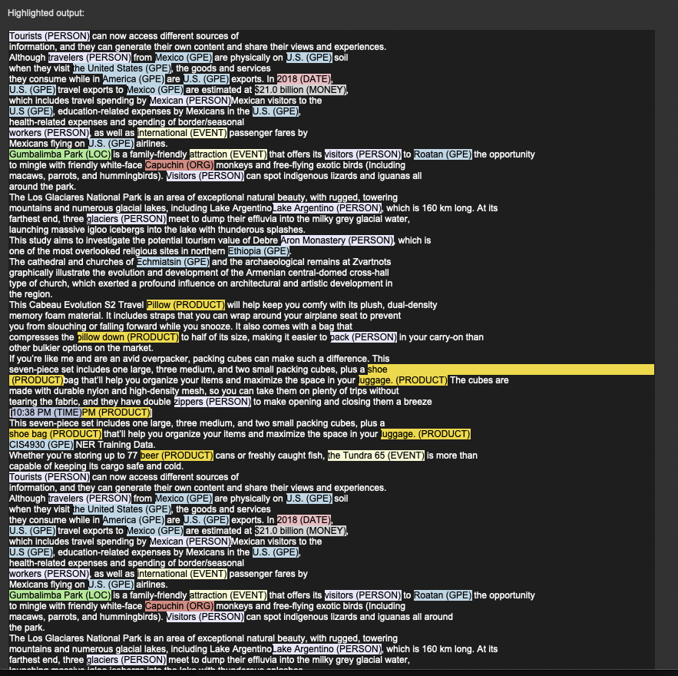

6. Analysis of Results (3 points)
- Analysis:
  - The program properly trains a model using Spacy for named entity recognition. It allows the user to paste in specific text, which highlights domain-related entities and presents them in the output.
  - The model was trained by being given fifteen different sample texts related to the domain of “Travel and Tourism,” specifying which words from the text would be related to the entities used for the highlighting.
  - The more sample text we gave to our model, the more accurate it became in recognizing entities from other texts related to our travel and tourism domain topic.
  - Important: During the program analysis, we noticed that we sometimes had to click twice for the trained data to appear. This will be revised in the next version.

7. Conclusion (1 point)
- Summary:
  - We successfully built a simple frontend interface and used Python's spacy library to allow a user to paste text and highlight it using an NRE model. We also built our own training data from a variety of sources, which enabled the named entity recognition model to better recognize our domain entities.

  - The program successfully labels each entity found on the text and highlights them with their respective color. Building a GUI from scratch and adequately training the model for our specific travel and tourism domain.

  - As for my contributions, I worked on the training model, properly feeding it the text related to our domain, ensuring it was picking up the words we wanted to relate to the specific entities, working on the building of the spacy model inside the main script, and helped with the documentation of the program. Contributed on the coordination of setting up the GUI working alongside my group members.
  - We distributed our workflow as a discussion of tasks needed and assigned them according to the problems and challenges, we found when building our project.

8. Additional Comments (Optional) (bonus 1 point)
- Feedback/Comments:
  - We made many assumptions, and hopefully, we met expectations.
  - Figuring out how to train our spacy model efficiently was our biggest challenge, as the number of sample texts that had to be given for it to be trained efficiently was not specifically understood when we started.
  - Our training model relied on the indexes of the sample text; we would have liked more guidance on that aspect.

